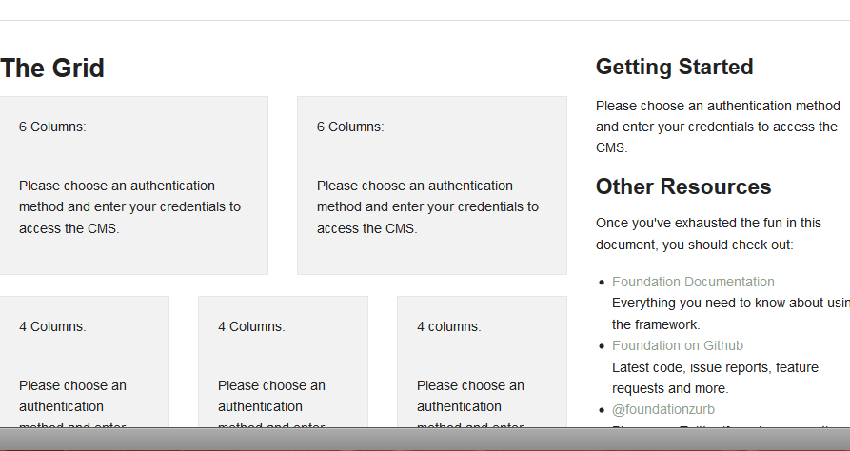

[User Error] Couldn't run query: SHOW TABLES LIKE 'SiteConfig' No database selected
GET /Security/login?BackURL=%2Fadmin%2Fpages

Line 580 in C:\WWW\MissPLampworkSS\framework\model\MySQLDatabase.php
Source

571 }
572
573 public function databaseError($msg, $errorLevel = E_USER_ERROR) {
574 // try to extract and format query
575 if(preg_match('/Couldn\'t run query: ([^\|]*)\|\s*(.*)/', $msg, $matches)) {
576 $formatter = new SQLFormatter();
577 $msg = "Couldn't run query: \n" . $formatter->formatPlain($matches[1]) . "\n\n" . $matches[2];
578 }
579
580 user_error($msg, $errorLevel);
581 }
582
583 /**
584 * Return a boolean type-formatted string
585 *
586 * @param array $values Contains a tokenised list of info about this data type

Trace

Couldn't run query: SHOW TABLES LIKE 'SiteConfig' No database selected
MySQLDatabase.php:580
MySQLDatabase->databaseError(Couldn't run query: SHOW TABLES LIKE 'SiteConfig' | No database selected,256)
MySQLDatabase.php:132
MySQLDatabase->query(SHOW TABLES LIKE 'SiteConfig')
MySQLDatabase.php:793
MySQLDatabase->hasTable(SiteConfig)
Database.php:468
SS_Database->hasField(SiteConfig,ClassName)
DataObject.php:193
DataObject::database_fields(SiteConfig)
DataQuery.php:396
DataQuery->selectColumnsFromTable(SELECT DISTINCT FROM "SiteConfig",SiteConfig)
DataQuery.php:188
DataQuery->getFinalisedQuery()
DataQuery.php:380
DataQuery->firstRow()
DataList.php:716
DataList->first()
DataObject.php:2844
DataObject::get_one(SiteConfig)
SiteConfig.php:162
SiteConfig::current_site_config()
ContentController.php:121
ContentController->init()
Page.php:32
Page_Controller->init()
Security.php:354
Security->login(SS_HTTPRequest)
Controller.php:205
Controller->handleAction(SS_HTTPRequest)
RequestHandler.php:184
RequestHandler->handleRequest(SS_HTTPRequest,DataModel)
Controller.php:153
Controller->handleRequest(SS_HTTPRequest,DataModel)
Director.php:307
Director::handleRequest(SS_HTTPRequest,Session,DataModel)
Director.php:119
Director::direct(Security/login,DataModel)
main.php:126

